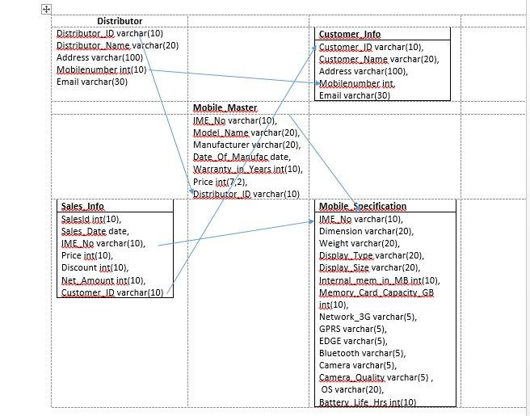

1. Write a Query to Display the mobile details such as IMENO, ModelName,Manufacturer produced by the manufacturer Nokia.

**Ans----select IME_NO,Model_Name,Manufacturer from Mobile_Maser where Manufacturer=’Nokia’;**

2.Write a Query to display IMENO, ModelName, Manufacturer, Camera Quality of mobiles whose camera quality is 5MP.

**Ans---select IME_NO, Model_Name,Manufacturer,Camera_Quality from Mobile_Specification inner join Mobile_Master on Mobile_Specification.IME_NO=Mobile_Master.IME_NO where Camera_Quality=’5MP’;**

3.Write a Query to display the distributor details such as distributor name,mobile number and email of the Mobile model 'MicromaxQ5'.

**Ans-----select Distributor_Name,Mobile_Number, Email form Distributor inner join Customer_Info inner join Mobile_Master on Distributor.Mobile_Number=Customer_Info.Mobile_Number AND Distributor.Distributor_ID=Mobile_Master.Distributor_ID where Mobile_Model=’MicromaxQ5’;**

4.Write a Query to display mobile model, manufacturer and price for the mobiles having a price range from 8500 to 25300

**Ans----select Mobile_Model, Manufacturer, Price from Mobile_Master where Price BETWEEN 8500 and 25300;**

5.Write a Query to display the IMENO,model name,manufacturer,price and discount of all mobiles regardless of whether the mobile is sold or not.

**Ans---select IME_NO, Model_Name,Manufacturer,Price,Discount form Mobile_Master inner join Sales_Info inner join Mobile_Specification on Mobile_Master.IME_NO=Sales_Info.IME_NO AND Mobile_Specification.IME_NO=Mobile_Master where Discount=’sold’;**